Installation Manual
Decos XML Import Service 3.2.10

Contents
1. Minimum Software Requirement 3
2. Installation Steps 4
Note: For configuration Please refer User Manual. 5

Minimum Software Requirement

- Windows Server 2008/2012
- .Net Framework 4
- D6 Version -6.0.18 and above.

Installation Steps
  - If Xml Crawler already exists on the system, uninstall it from Add Remove program.
  - Run the setup file under administrative privileges.
  - Click on Next to continue with the installation:
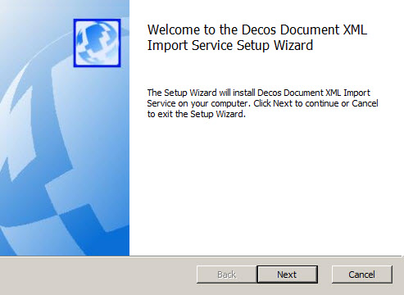

  - Specify the path where you want to install the service.
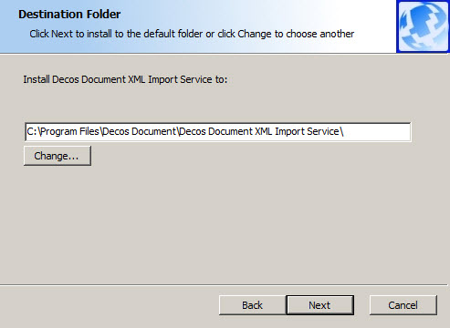

  - Click on Install to install the service:
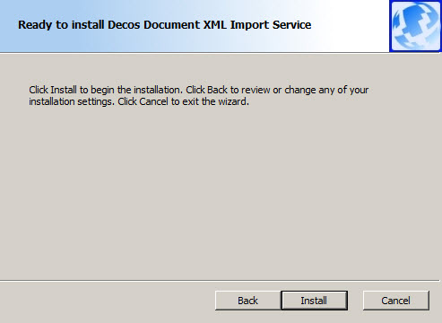

  - Click on Finish to complete the installation.
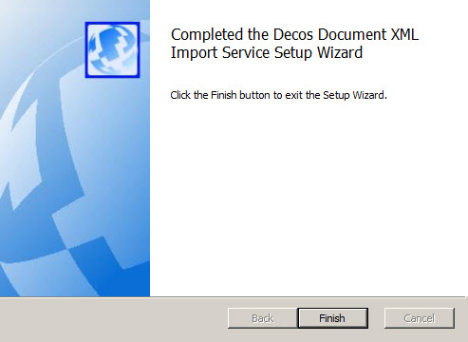

Note: For configuration Please refer User Manual.

